Below are graphics of how the Web Advisor screens will look as you navigate through to enter your Final Semester Grades. You have approximately 30 minutes to enter the grades before the system times you out. With this in mind it would be appropriate to have all of your grades ready for entry prior to logging in to Web Advisor.

The web address to WebAdvisor, on or off campus is:

www.webadvisor.scccd.edu.

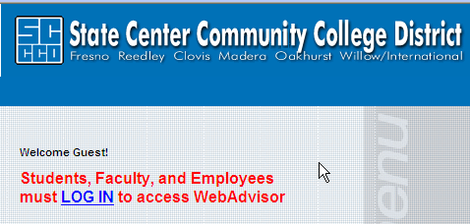
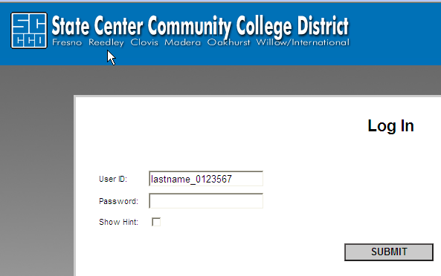

Click on LOG IN

If you have not used WebAdvisor before, your User ID is as follows:

lastname_0123567 (e.g., smith_0330965)

Your default password is your birth-date MMDDYY (e.g. 102108)

As you enter the ”Faculty” site you will see the following screen.
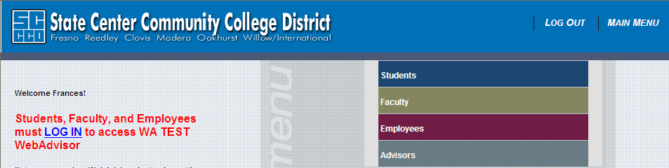
Step 1. Under Faculty Informatin click your mouse on the “GRADING” option. The next screen will be:
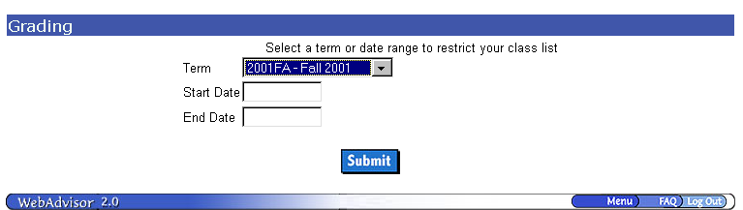
SELECT THE APPROPRIATE TERM

Step 2. Click on the drop down arrow and select the appropriate term and click on the Submit button.
The next screen will be:

Step 3. Click on the arrow box and select “F-Final”; then click on the class for which you will be entering grades. A check mark will appear in the box for the class chosen, then click on the submit button. You may only enter the grades for one class at a time. The next screen will be where the grades are actually entered.

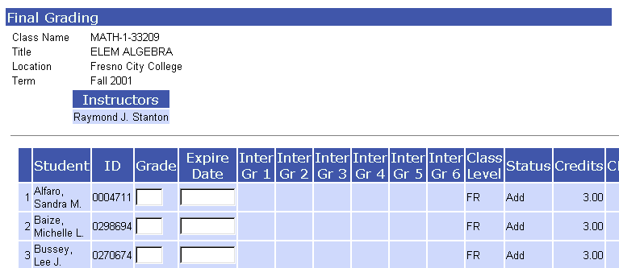
Step 5. Students who appear on this Final grading screen should be those who are to receive a grade. Enter each student’s A, B, C, D, F or I letter grade, DO NOT ENTER A “W”, AS THIS IS NOT A GRADE, LEAVE THE GRADE FIELD BLANK and contact Admissions & Records.

An “Expire Date” (MMDDYY) must be entered for “I” Incomplete grades (this is the date the student is to have his/her conditions completed, such as 051009)

If you have left any student’s grade field blank, please contact frances.lippmann@fresnocitycollege.edu upon the electronic submission of your roster.

Once you have entered the grades and an Expire Date, when appropriate, click on the Submit button.

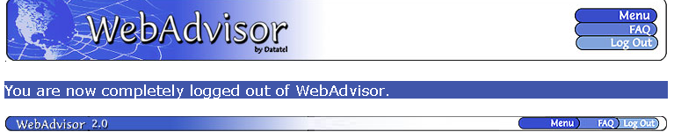
Step 6. If you have more classes to enter, click on the menu button and this will take you back to Step 1. If you are done entering your grades make sure you click on the “Log Out” button. When logged out you will receive the message above.

